SIMATS ENGINEERING
NAME: A.Preetika Sudhakar
RREG NO. 192371073
COURSE NAME: Database Management Systems
COURSE CODE: CSA0501

2. DDL Commands with Constraints – PRIMARY, FOREIGN KEY, UNIQUE, CHECK
AIM:
To add the constraints like primary key, foreign key, unique key and check using DDL commands.
Description:
PRIMARY KEY:
The PRIMARY KEY constraint uniquely identifies each record in a database table.
Primary keys must contain UNIQUE values, and cannot contain NULL values.
A table can have only one primary key, which may consist of single or multiple fields.

FOREIGN KEY:
➢ A FOREIGN KEY is a key used to link two tables together.
➢ A FOREIGN KEY is a field (or collection of fields) in one table that refers to the
PRIMARY KEY in another table.
➢ The table containing the foreign key is called the child table, and the table containing the candidate key is
called the referenced or parent table.
UNIQUE Constraint:
➢ The UNIQUE constraint ensures that all values in a column are different.
➢ Both the UNIQUE and PRIMARY KEY constraints provide a guarantee for uniqueness for a column
or set of columns.
➢ A PRIMARY KEY constraint automatically has a UNIQUE constraint.
➢ However, you can have many UNIQUE constraints per table, but only one PRIMARY KEY
constraint per table.

CHECK Constraint:
➢ The CHECK constraint is used to limit the value range that can be placed in a column
➢ If you define a CHECK constraint on a single column it allows only certain values for this column.
➢ If you define a CHECK constraint on a table it can limit the values in certain columns based on
values in other columns in the row.
PRIMARY:
ALTER TABLE table_name
ADD PRIMARY KEY(primary_key_column);

FOREIGN KEY:
ALTER TABLE table_name
ADD CONSTRAINT constraint_name
FOREIGN KEY foreign_key_name (columns)
REFERENCES parent_table(columns)
ON DELETE action
ON UPDATE action
UNIQUE:
CREATE TABLE table_1(
...
column_name_1 data_type,
...
UNIQUE(column_name_1)
);
CHECK
CREATE TABLE IF NOT EXISTS parts (
part_no VARCHAR(18) PRIMARY KEY,
description VARCHAR(40),
cost DECIMAL(10 , 2 ) NOT NULL CHECK(cost > 0), price DECIMAL (10,2) NOT
NULL
);
Questions:
- Add PRIMARY KEY to PLOTS
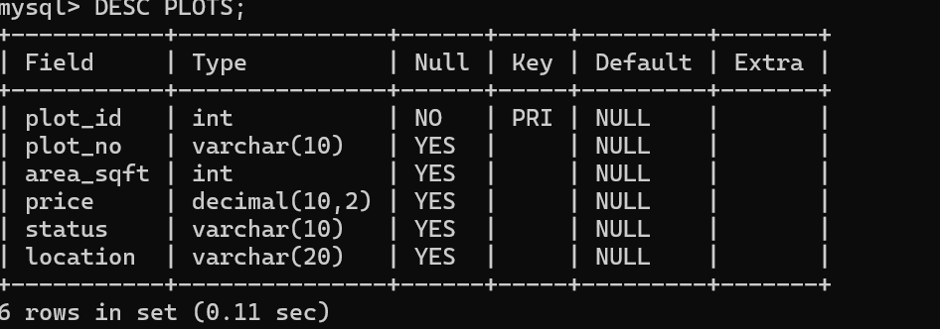

2) Alter the table name with following structure.
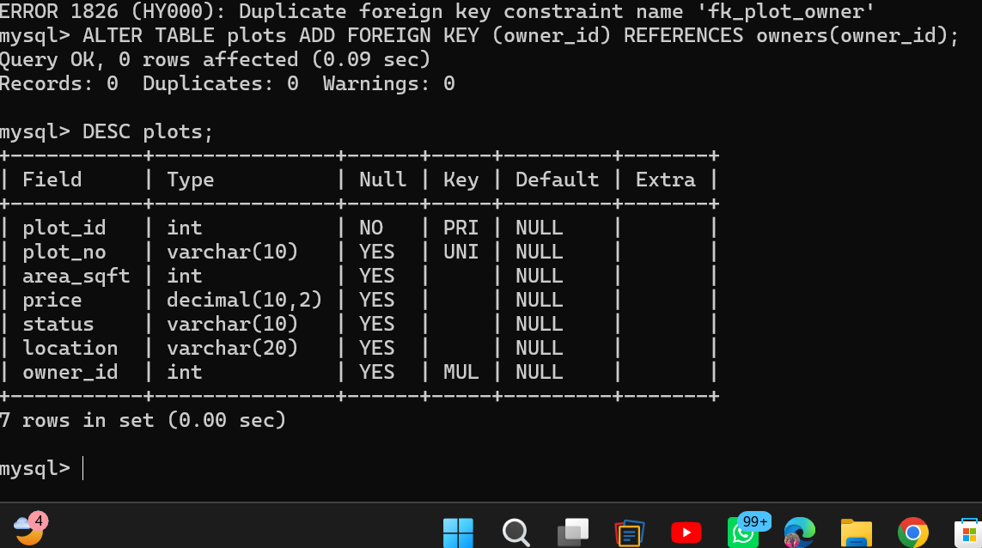

3.Add a UNIQUE constraint to plot_no.

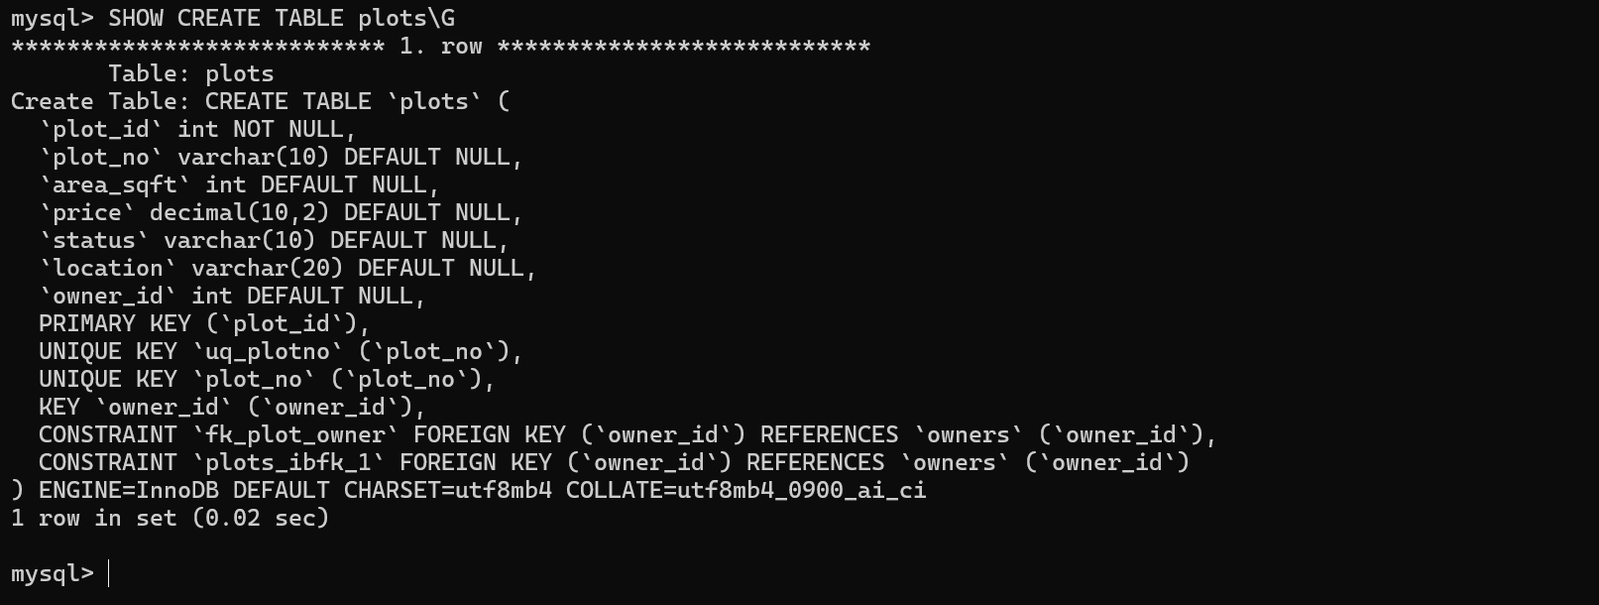

4. FOREIGN KEY

